5. Climate
During my absence in the first half of 2004, some of the rain-gauge measuring sticks were lost. As a result rangers used some other sticks that are calibrated differently. Unfortunately, both types of measuring stick were used during these months making it impossible to trace which calibration was used at which location and date. For this reason and the fact that there is significant numerical overlap between the two calibrations, it was not possible to simply convert the incorrect measurements. In addition, some data was lost or not recorded (see table 4.1). Outstation rainfall data over this period should be discarded as it is highly counterproductive to use dubious climate data when investigating climate related phenomena.

Table 4.1: Outstation rain gauge readings. Figures in red are those where it is uncertain
which calibration was used. During January to June, no research officer was
present

 | A.Var | B.Lebine | CC.G | CC.H | DDM | DJL | Gionnet | I.Esprit | MC | Polymnie
January | 60 | 245 | o/flow | 250 | 45 | 45 | 40 | 172 | 20 | 90
February | 60 | 58 | 205 | 240 | 310 | 225 | 230 | 220 | 410 | 120
March | 100 | 140 | 165 | 115 | 55 | 162 | 75 | 135 | 65 | 10
April | 25 | 10 | 23 | 40 | 58 | 55 | 80 | 35 | 85 | 70
May | 12 | 30 | 41 | 55 | 42 | 58 | lost | 5 | 35 | lost
June | 50 | 45 | lost | 25 | 40 | 20 | lost | - | 5 | lost
July | 20 | 28 | 26 | 20 | 12 | 5 | 10 | 55 | 42 | 13
August | 30 | 45 | 54 | 80 | 55 | 60 | 55 | 12 | 30 | 48
September | 1 | 10 | 10 | 12 | 5 | 2 | 16 | 5 | 0 | 15
October | 15 | 15 | 19 | 15 | 97 | 140 | 4 | 3 | 25 | 20
November | 130 | 122 | 111 | 115 | 1 | 14 | 120 | 90 | 112 | 107
December | 30.1 | 52 | 30 | 22 | 35 | 31 | 10 | 275 | 5 | 20

The automatic weather station broke down completely in July. This condition has remained unchanged and as a result, no wind speed and direction data has been recorded for that period.

Manual temperature and rainfall readings have been taken regularly at the station. Mean temperature and rainfall have shown typical patterns (figure 4.1 & 4.2).

Mean rainfall figures for outstations between 1999 and 2004 show significant variation only between the Anse Var and Cinq Cases Groves gauge (figure 4.3). Mean annual precipitation between 1999 and 2004 shows significant variation. The year 2000 shows particularly low precipitation (figure 4.4). The years prior to 1999 were omitted from the analysis due to incomplete records. It must also be noted that values for 2004 are subject to error due to the calibration problems in the first half of that year.

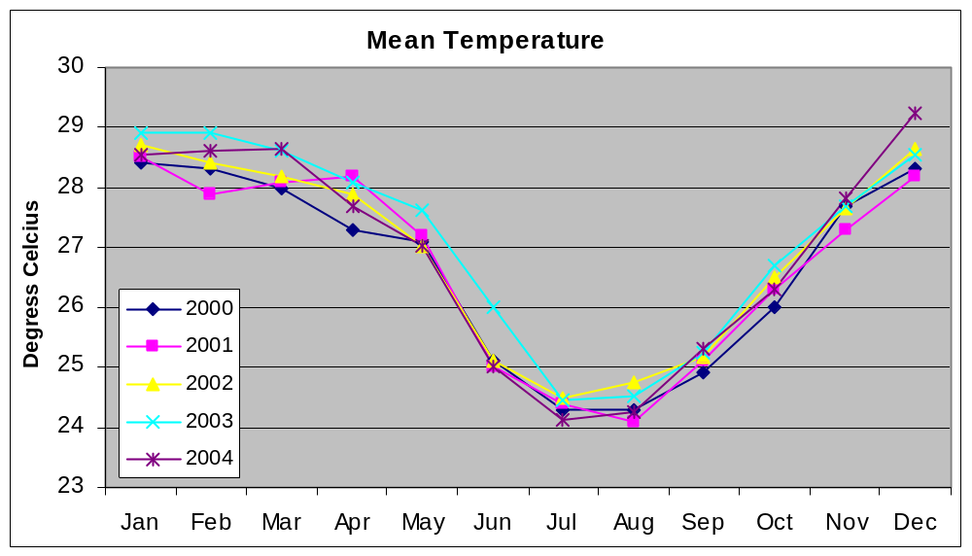

Figure 4.1 Mean dry bulb temperature between 2000 and 2004

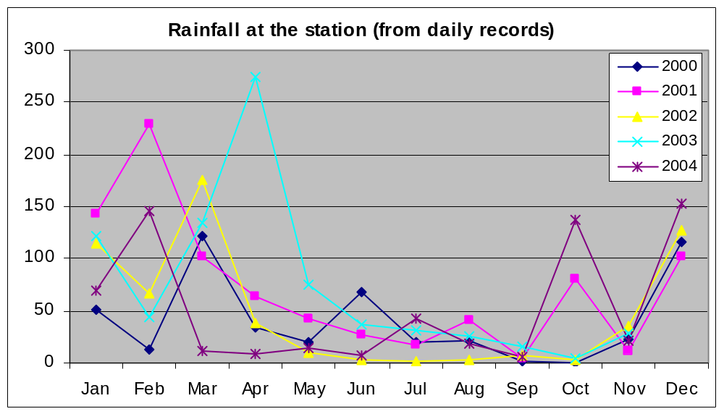

Figure 4.2 Rainfall at the station between 2000 and 2004

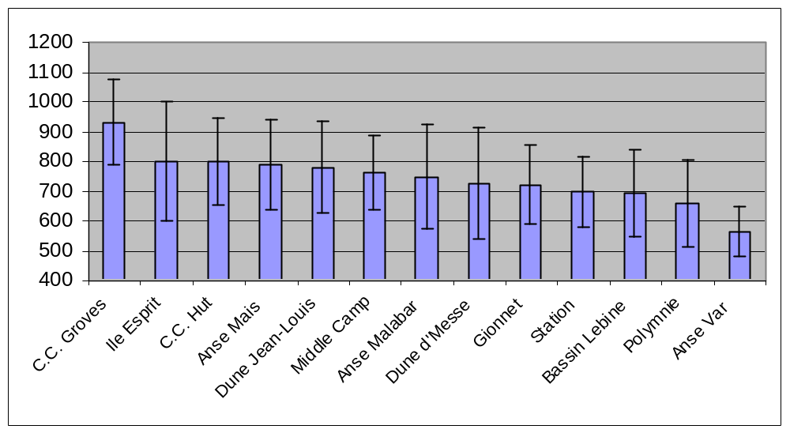

Figure 4.3 Mean precipitation at the various outstations (1999-2004)

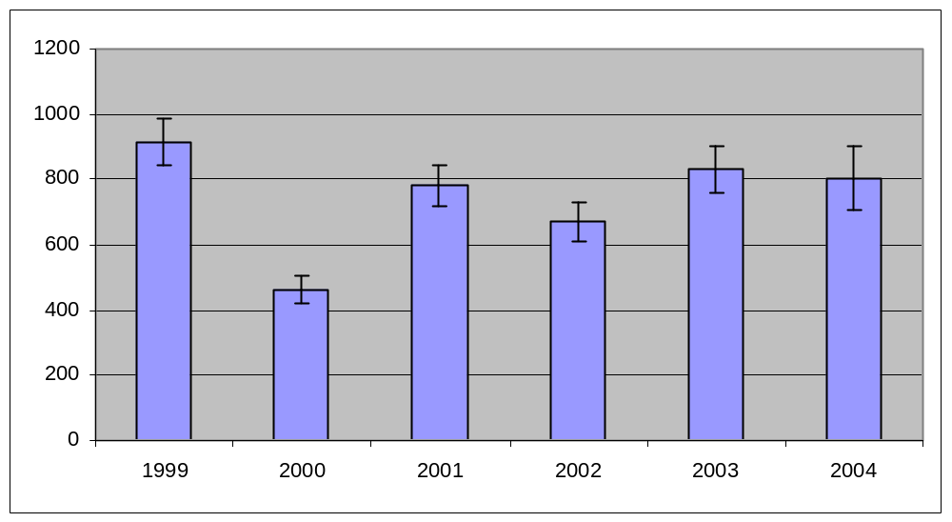

Figure 4.4 Mean annual precipitation at Aldabra (1999-2004)

